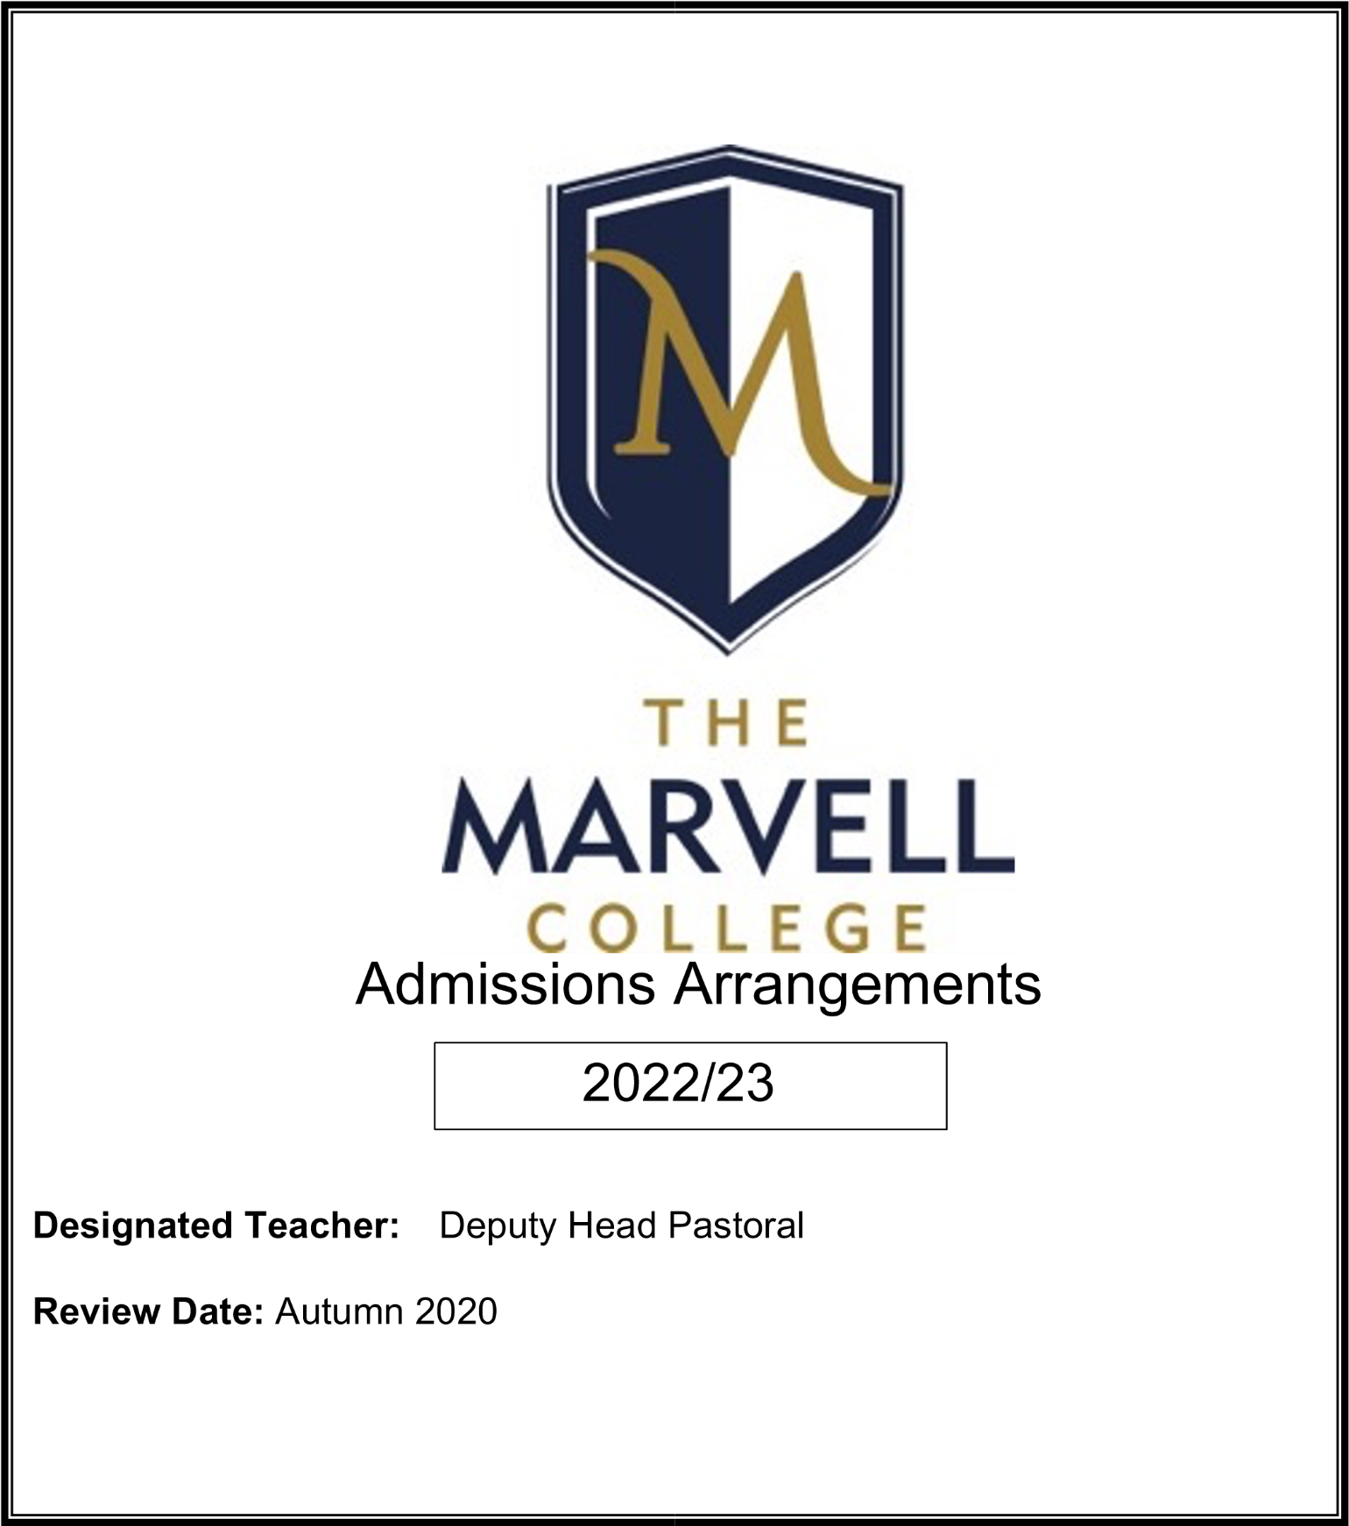
2023/2024
(A Booth)
Autumn 2023

HULL COLLABORATIVE ACADEMY TRUST (HCAT)
The Marvell College
Secondary School Admissions 2023/24

Background
On 1 July 2013 Bellfield, Collingwood, Eastfield, Thoresby and Wansbeck Primary Schools converted to academy status, and joined together to form Hull Collaborative Academy Trust (HCAT). The Trust has now 14 primaries including Dorchester, Gilberdyke, Longhill, Stockwell, Sutton Park, Pearson, Westcott, Wheeler, Withernsea.
Upon conversion, the Academy Trust became its own admissions authority; this means it is responsible for setting its own admissions arrangements.
On 1 September 2016 The Marvell College joined HCAT as a sponsored Academy and the only secondary school within the Trust. As such, admissions arrangements for The Marvell College differ slightly from those of other schools within the Trust.
The Local Authority (Hull City Council) continues to be responsible for coordinating all admissions in their area, and making offers of places.
Further details on how to apply for a school place can be found on the council’s website www.hullcc.gov.uk/admissions.

2. Admission Arrangements

Admission Number: 240 (previously 260)
The admission arrangements set out how many children the schools will admit and how they will decide which applicants will qualify for places if the number of applications is more than the number of places available.
For the school year 2023/24 The Marvell College will use the following admission arrangements.
Applications for pupils with Education and Health Care Plans (EHCP) will be dealt with in accordance with the Code of Practice on Special Educational Needs. Where a school is named in a child’s statement following consultation with the Head and Governors, the governing body are required to admit the pupil. After the allocation of pupils with EHCP, where the number of applications is greater than the remaining places the following criteria will be applied in the order set out below:

- Children in public care at the time when preferences are expressed and who are still in public care at the time of their admission to school, and those who have been previously looked after including children who were previously looked after outside England but ceased to be so because they were adopted or became subject to a child arrangements order or special guardianship order.

- Significant medical factors or exceptional family circumstances. (See note (i) below)

- Admission authorities may give priority in their oversubscription criteria to children of staff in either or both of the following circumstances:
- Where the member of staff has been employed at the school for two or more years at the time at which the application for admission to the school is made, and/or
- The member of staff is recruited to fill a vacant post which there is a demonstrable skill shortage.

- Being a resident in our confirmed catchment area.

- Those applicants who on the date of admission will have a sibling on roll at The Marvell College. See notes (ii) and (iii) below.

- Geographical, with priority given to those living nearest to the school (see notes (ii) and (iv) below)

Criteria 5 and 6 will be used as a tie-breaker for other criteria.

Notes

- Significant medical needs must be supported at the time of application by a letter from a GP, hospital consultant or other medical professional indicating how a pupil’s medical condition relates to the school preference.

Exceptional family circumstances must be supported at the time of application by a letter from a supporting agency (eg. Social Worker or Family Support Worker) indicating how the circumstances relate to the school preference. These applications will be given consideration under a review procedure in advance of school allocations being completed.

- Residence is defined as the normal family address where the child resides, however it may also include both addresses where the child resides if living between two properties. The qualification date is the closing date for applications under the coordinated admissions scheme. (Where families change normal address after the closing date but before the allocation process has finished this can be considered under the review procedure).

- Brothers and sisters include:
  - children with the same natural parents living at the same address
  - children with the same natural parents living at different addresses (eg due to separation of natural parents)
  - half-brothers/sisters living at the same address
  - step brothers/sisters living at the same address
  - foster children living at the same address
  - children living as part of the same family unit with their parents/guardians at the same address.

- The measurement of distance is the shortest available safe route for pedestrians along footpaths, using footpaths alongside roads marked on the current street map of the City. Front entrance of home property (residence) to main entrance of school site is used. The Authority will use Routefinder, a computer mapping system, to make measurements

- The highest priority must be given to looked after children^{1 ,} , children who were previously CLA out of England and children who were looked after, but ceased to be so because they were adopted² or became subject to a residence order³ or guardianship order⁴. Further references to previously looked after children in the Admissions Code means children who were adopted (or subject to residence orders or special guardianship orders) immediately following having been looked after.

Waiting Lists
Subject to any provisions regarding waiting lists in the coordinated admission scheme, the College will operate a waiting list set by the Local Authority. Where in any year the College receives more applications for places than there are places available, a waiting list will operate until the end of the first school term automatically. If the parent or carer wishes to remain on the waiting list for the full academic year this can be communicated in writing to the Local Authority. Places from the waiting list will be offered in the priority order set out above, not in order of the date applications are made.

Appeals
The Marvell College delegates the responsibility of appeals to an independent panel and are the responsibility of the college. Parents who wish to appeal the decision to refuse their child a place at the College may apply in writing to the LA/College where appeals will be heard by an independent panel.

The Marvell College can be contacted at the following address:
Mr J Capper
Headteacher
The Marvell College,
Barham Road, Hull, HU9 4EE
01482 799132
admin@themarvellcollege.com

Fair Access Protocols
The College works in accordance with the in-year Fair Access Protocols held by the Local Authority; should a vulnerable child within the protocols require a place at the College, they will take precedence over any child on the waiting list.

In Year Admissions
The College will co-ordinate their own in year admissions with the Local Authority and an application made outside the normal admissions round (in-year admissions) should be made directly to the Local Authority. Parents/carers can apply for a place for their child at any time and to any school. On receipt of an in-year application, the Local Authority will notify the College of the application and it’s the College will inform the Local Authority of the outcome and the LA will confirm whether an offer of a place can be made. If no place can be offered the right reason for the refusal will be given and the LA will confirm this to the applicant and offer the right of appeal against the decision.
Applications Outside of Chronological Year Group:
Parents/carers may seek a place for their child outside of their normal (chronological) age group, for example, if the child is exceptionally gifted and talented or has experienced problems such as ill health.
Parents do not have the right to insist that their child is admitted to a particular year group. The Marvell College will admit children outside their normal age group only in exceptional circumstances. If parents wish their child to be admitted outside their normal age group they must still make their application alongside children applying at the normal age and must make their request for admission outside the normal age group clear on their Application Form to the Local Authority for a school place. At the same time, parents should also write to the Headteacher if they wish to request admission out of the normal age group, explaining why it is in the child’s best interests and include information such as professional evidence as to why this is the case and why an exception should be made in the case of the child. The decision made by the school will be based on the individual circumstances of each case and in the best interests of the child concerned.

Fraudulent Applications:
Should a place be allocated using fraudulent applications information the offer of a place may be withdrawn.

How and When to Apply
Applications for a primary to secondary place must be made on the Local Authority Common Application Form. All forms must be returned by the closing date: 31st October.
Any applications received after the closing date will be accepted but considered only after those received by the closing date.
In regards to an ‘In Year Transfer’ application, all local authorities have both on-line and paper application forms. Please visit your local authority’s website for more specific information on how to apply.
The Marvell College is in the Hull City Council local authority. Hull City Council's admissions information can be found on their website.
Further details on how to apply for a school place can be found on the council’s website www.hullcc.gov.uk/admissions
Admissions Team Contact Details:
Admissions Team
Children and Young People’s Services
Hull City Council
Kingston House
Bond Street
Hull
HU1 3ER
Tel: 01482 300 300
For more information please contact Miss Booth (Deputy Headteacher) Tel: 01482 799132. Email: abooth@themarvellcollege.com

- A 'looked after child' is a child who is (a) in the care of a local authority, under a Child Arrangement Order or (b) being provided with accommodation by a local authority in the exercise of their social services functions (see the definition in section 22(1) of the Children Act 1989).
- Under the terms of the Adoption and Children Act 2002. See section 46 (adoption orders).
- Under the terms of the Children Act 1989. See section 8 which defines a ‘residence order’ as an order settling the arrangements to be made as to the person with whom the child is to live.
- See section 14A of the Children Act 1989 which defines a ‘special guardianship order’ as an order.
5. This includes children who have been in state care outside England and have been adopted. State Care includes those looked after by a public authority, a religious organisation or another provider of care whose sole purpose is to benefit society. The care may have been provided in orphanages or other settings.

