Year 1
Name ______________________
Work-at-Home Pack 6

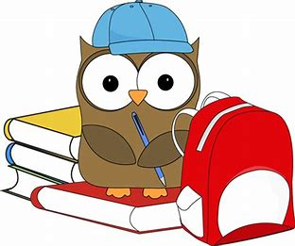

Monday
Writing Numbers
Start at the green arrow. Finish at the red dot.

Monday
Maths – Basic Skills – Counting
Geography – Maps

Here is an aerial view of the school.
Can you find:
- the field
- the playground
- the car park
- the sports hall

What else can you find?

Tuesday

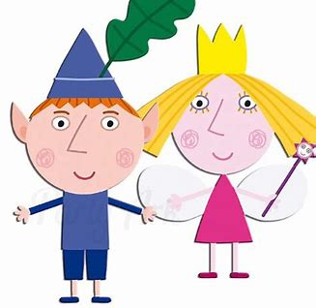

Tuesday
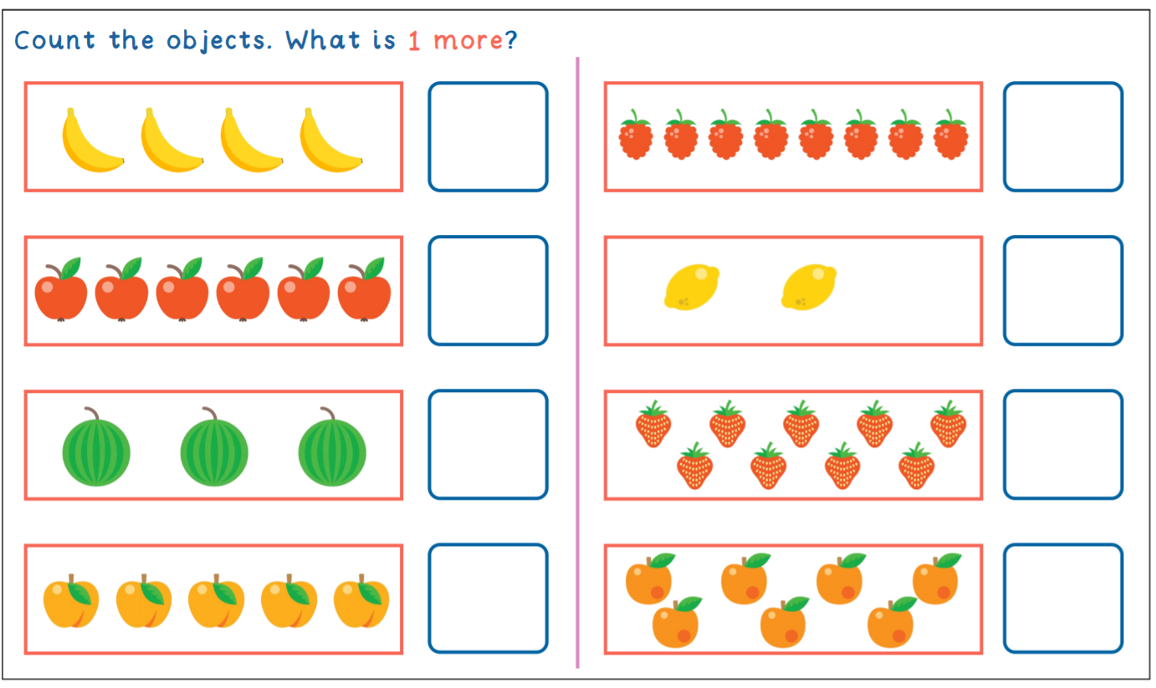
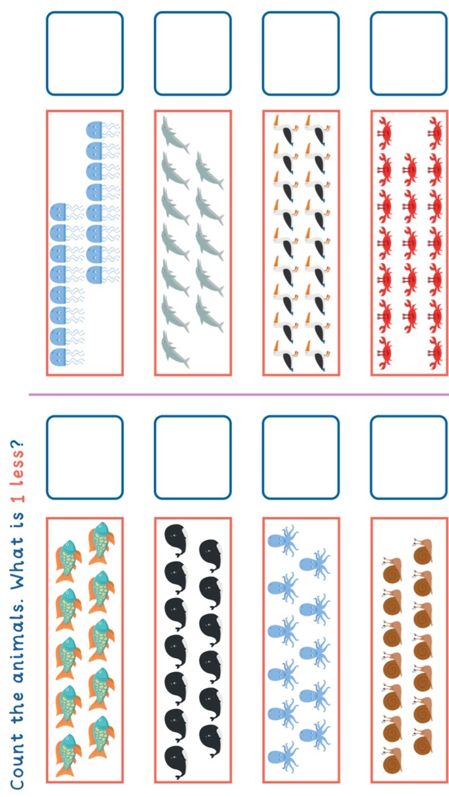
Basic Maths – Counting – 1 more and 1 less

Tuesday
Wider maths – measurement – capacity

Cut out the labels and stick them below correct picture.

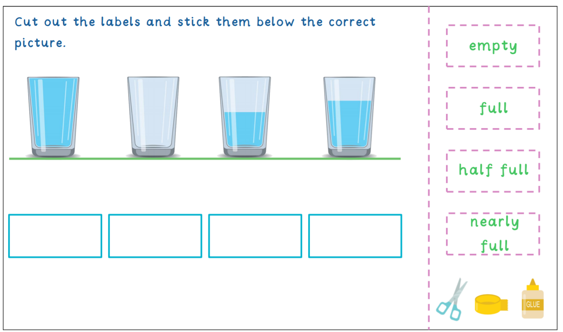

Tuesday
Reading
Read each sentence then draw a picture about it.
1. The three boys were sleeping in a blue car.

2. The little goat was on a pink boat.
Tuesday
3. A brown cow in the shower!
Writing
Write a sentence about what you see in the picture:

Wednesday

Wednesday
Basic Maths

Count in 1s:

3, _____, ______, 6

Count in 2s:

2, 4, 6, ______, _______

Count in 5s:

10, 15, ______, _______

Count in 10s:

20, _______ ________, _______

WednesdayWednesday

Phonics – ‘ai’ sound

Can you find any things around your house that have an ‘ai’ sound?
Write them down in the box:

Wednesday
Writing

Choose one of the words. Write a sentence including the word.

Wednesday
Science

Thursday

Thursday

Basic Maths – Counting in 2s
Start at 2. Count int 2s.
Colour in all of the numbers that you count. E.g. 2, 4. 6, 8, 10 …….

Thursday

Phonics – ‘ow’ sound

Can you find any things around your house that have an ‘ow’ sound?
Write them down in the box:

Thursday
Writing
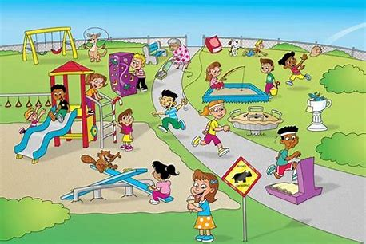
Write about what you see in the picture:

Friday

Friday
Maths - Addition

5 + 5 + 1 =

3 + 2 + 1 =

7 + 2 + 0 =

3 + 3 + 3 =

Friday
Maths – 3D Shape

Can you name any of the shapes?

Friday
Art – Colouring

Friday
Handwriting
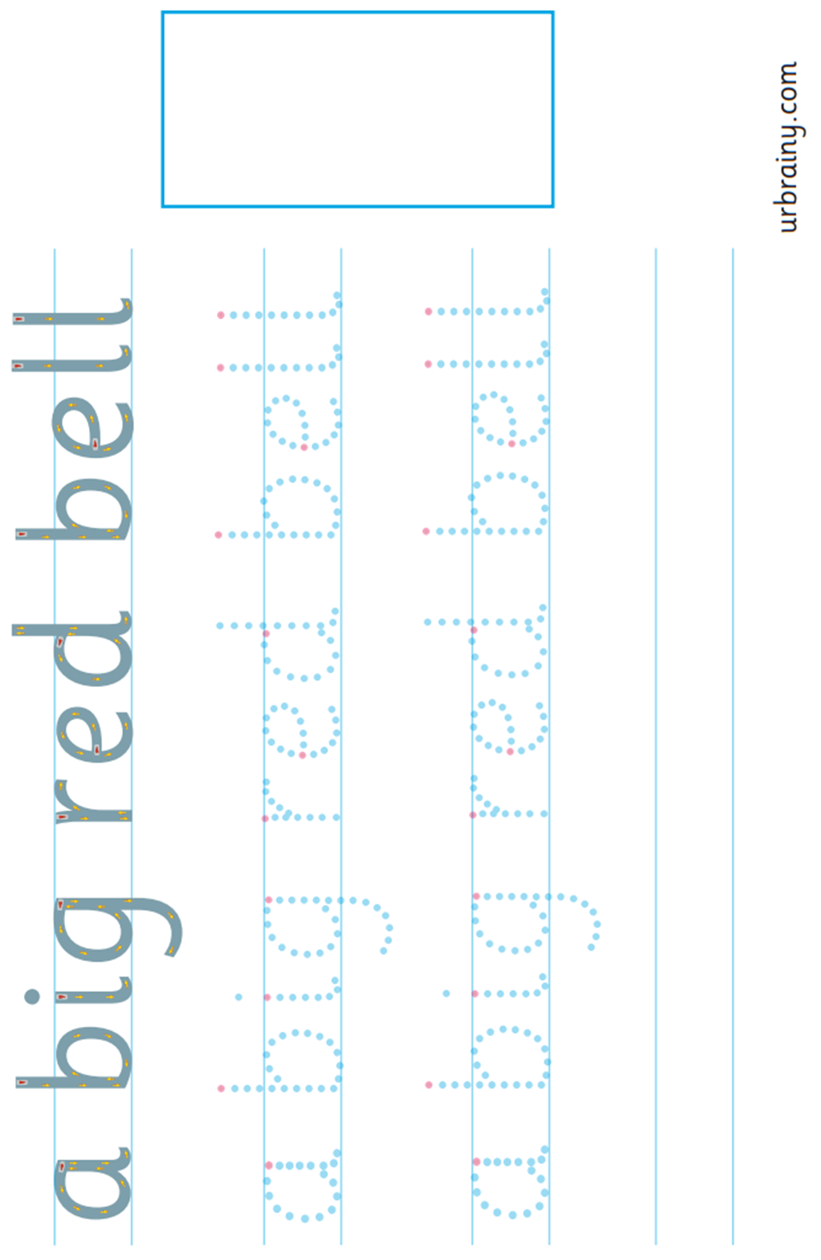

Year 1
Name ______________________
Work-at-Home Pack 7

Monday
Writing Numbers
Practise Time Again!
Start at the green arrow. Finish at the red dot.

Monday
Maths – Basic Skills – Counting

Now order each of the numbers from smallest to greatest.

Monday
Wider Maths – Measurement – Tall and Short

Taller Than | Shorter Than

Monday
Phonics - ‘oa’:

Can you find any things around your house that have an ‘oa’ sound?
Write them down in the box:

Monday
Geography – Maps

Label the Compass:
North South East West

Tuesday

Tuesday
Wider maths – Tall and Short
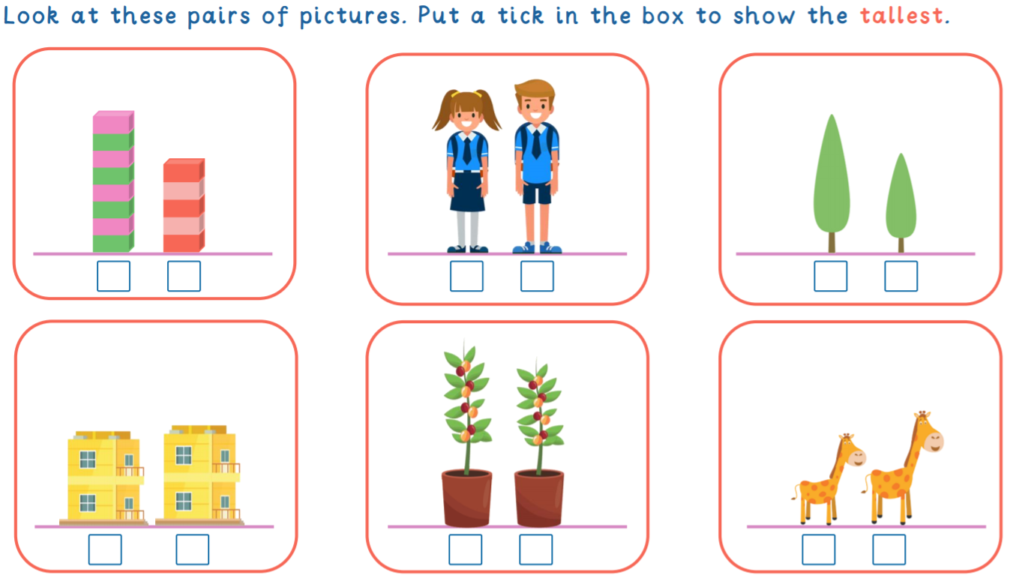

Tuesday
Reading
Read each sentence then draw a picture about it.
1. A mouse with a blue tail is in a tall house.

2. The clown with a frown dances around the town.
Tuesday
3. A girl with a red skirt plays on the swing.
Writing
Write about what you see in the picture:
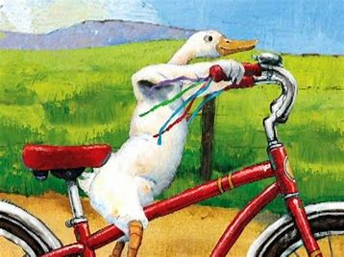

Wednesday

Wednesday
Basic Maths – Counting backwards:

20, 10, 18, ____, _____

100, 99, 98, _____, ____

10, 8, 6, _____, _____

40, 30, 20, ______

20, 15, _____, ______

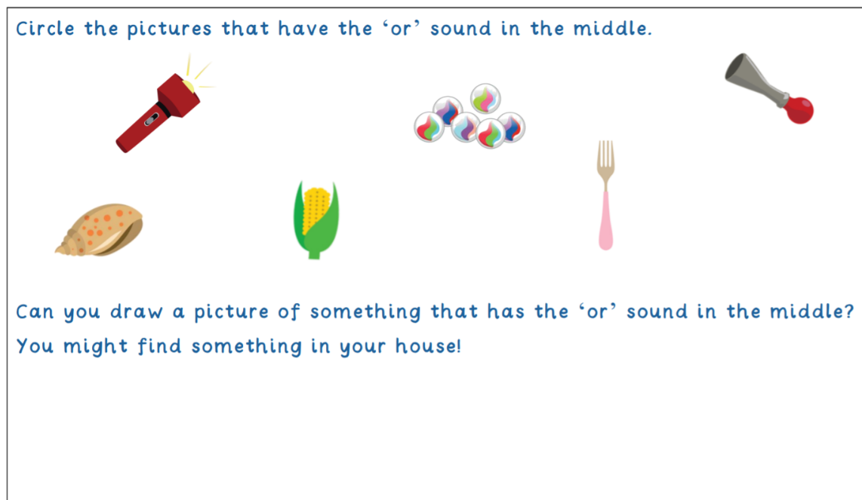
Wednesday

Phonics – ‘or’ and ‘er’ sounds

Wednesday
Reading Comprehension

1. Describe the tiger in two words.
__________________________________________________

2. Why did the tiger knock on the door?
__________________________________________________

3. How do you think Sophie felt?
__________________________________________________
__________________________________________________

Thursday

Thursday

Maths

Thursday
Phonics – ‘ee’ sound
Chose one of the ‘ee’ words. Write a sentence with the word in it.

ite a sentence with the word in it.

Can you think of any other words with ‘ee’ sounds?

Thursday
Science

Thursday
Handwriting
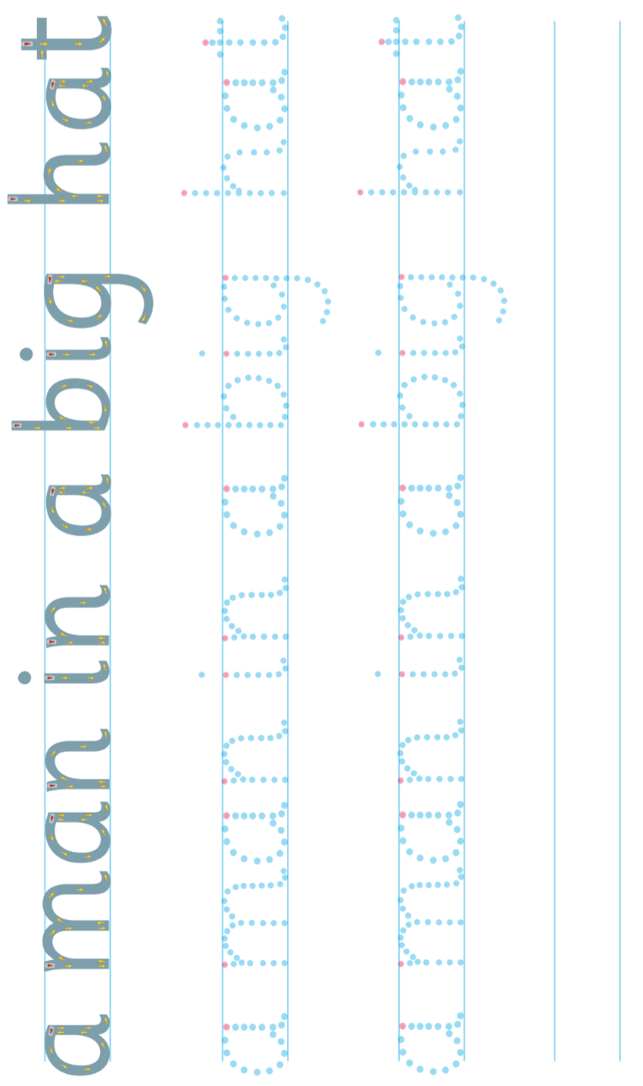

Friday

Friday
Spellings
Practise:

one
two
three
four
five
six
seven
eight
nine
ten

Ask an adult to test you!

Friday
Geography

England Scotland Wales Northern Ireland
Friday

